UNIVERSITY OF IBADAN

RESEARCH WORK

ON

CLOUD/WEB HOSTING

BY

OMAGE MICHEAL BRIGHT
233 353

September 26, 2023

Table of Contents

- Introduction
1.1 Background
1.2 Problem Statement
1.3 Research Questions
1.4 Research Aims and Objectives

- Literature Review
2.1 Overview of Cloud Hosting
2.2 Overview of Web Hosting
2.3 Security Considerations
2.4 Compliance Considerations

- Methodology
3.1 Research Design
3.2 Sampling
3.3 Data Collection Methods
3.4 Quantitative Data Analysis
3.5 Qualitative Data Analysis
3.6 Data Integration
3.7 Ethical Considerations

- Conclusion
4.1 Summary of Aims
4.2 Expected Outcomes
4.3 Limitations
4.4 Recommendations

- References

1. Introduction

  - Background


The landscape of IT infrastructure and web hosting has undergone a profound transformation in recent years, fueled by the rapid adoption of cloud computing and web hosting services. This transformative shift has redefined how organizations, including small businesses, approach the hosting and management of their digital assets. The evolution towards cloud and web hosting solutions has been driven by a compelling array of factors, including scalability, flexibility, and the potential for substantial cost savings.



The Prevalence of Cloud Computing

Industry surveys and statistics bear testament to the ubiquity and significance of cloud computing in contemporary business operations. Remarkably, over 90% of enterprises have embraced some form of cloud hosting [1]. This staggering adoption rate underscores the pivotal role that cloud infrastructure as a service (IaaS) plays in modern IT ecosystems. Furthermore, the global public cloud services market is poised for exponential growth, with projections indicating it may reach a staggering $500 billion by 2022 [1]. This meteoric rise attests to the unparalleled appeal of cloud-based solutions in meeting diverse organizational needs.

The Enduring Relevance of Web Hosting

Concurrently, the web hosting sector remains a stalwart in the digital realm, boasting an annual market value exceeding $100 billion [2]. Companies, both large and small, continue to rely on web hosting providers to facilitate the publication of their websites and web applications. This steadfast reliance on web hosting services underscores their enduring relevance in the digital landscape.

The juxtaposition of these two dynamic domains—cloud computing and web hosting—creates a compelling backdrop for our research. In particular, we are drawn to the intersection of these technologies and their impact on small businesses. While cloud hosting offers scalable and cost-effective solutions for IT infrastructure, web hosting remains a fundamental component of establishing a visible and accessible online presence. Thus, we seek to explore and evaluate the advantages and disadvantages of these hosting approaches within the context of small business operations.

By embarking on a mixed-methods research journey, encompassing quantitative surveys and qualitative interviews, we endeavor to provide actionable insights into the choices small businesses face when considering cloud and web hosting solutions. This study is poised to shed light on how these technologies align with the distinct requirements and aspirations of small business entities—a segment that forms the backbone of the global economy.

Our research aims to inform decision-makers, IT professionals, and small business owners about the merits and potential challenges associated with cloud and web hosting, enabling them to make informed choices that best suit their unique operational needs.

1.2 Problem Statement

While academic studies have analyzed high-level trends in cloud and web hosting adoption, there is a lack of research on the decision-making process of small businesses evaluating these solutions. Large enterprises have dedicated technical teams to manage complex cloud migrations and web hosting evaluations. Small businesses with limited IT resources face greater challenges in identifying the right cloud or web hosting provider and plan to meet their specific business needs and constraints. This knowledge gap regarding how small businesses can optimally leverage cloud and web hosting represents an open research problem.

1.3 Research Questions

This study aims to address the following key research questions:

- What are the main factors influencing small business decisions to adopt cloud hosting versus traditional web hosting?

- How satisfied are small businesses with key attributes like cost, security, reliability and scalability when using cloud versus web hosting solutions?

- What challenges do small businesses face in evaluating, selecting and managing cloud and web hosting providers?

1.4 Research Aims and Objectives

The overarching aim of this research is to provide data-driven guidance to small businesses on cloud and web hosting decisions. The specific objectives are:

1- Compare the advantages and limitations of cloud hosting versus web hosting for small businesses

- - Identify the drivers and barriers to small business adoption of cloud and web hosting

- - Evaluate small business satisfaction levels with cloud and web hosting across key attributes

- - Highlight challenges small businesses face in evaluating and managing cloud/web hosting

- - Provide recommendations to assist small businesses in selecting optimal cloud/web hosting strategies

This study collects empirical data from small businesses to address these objectives. The conclusions will aid owners in determining the best hosting approach to support their business goals and constraints.

- Literature Review

  - Overview of Cloud Hosting

A review of both academic and industry literature underscores the pivotal role of cloud hosting in reshaping modern IT infrastructure. Notably, cloud hosting offers several key benefits that have revolutionized the way organizations manage their digital assets.

According to Smith [2], one of the primary advantages of cloud hosting is its unparalleled scalability. Cloud platforms, exemplified by industry giants like Amazon Web Services (AWS), provide organizations with the ability to swiftly add or remove computing resources in response to fluctuating demand. This elasticity empowers businesses to optimize their IT expenditure, aligning it closely with their specific operational needs. Consequently, cloud hosting has emerged as a solution that seamlessly adapts to the dynamic nature of modern business environments.

Additionally, cloud hosting introduces the potential for substantial cost savings when compared to the traditional ownership and operation of on-premises data centers. Major cloud providers such as AWS have pioneered cost-effective models, including discounted pricing for long-term contracts and reserved capacity [2]. These pricing structures enable organizations to streamline their IT expenditure while benefiting from state-of-the-art infrastructure and services.

  - Overview of Web Hosting

In contrast, web hosting represents a more fundamental approach to hosting digital assets. Under this paradigm, a hosting provider rents server space to companies, enabling them to host their websites. Shared web hosting is a prevalent variant, where multiple customers share computing resources on the same server. While this approach allows hosting providers to offer cost-effective hosting plans, it does come at the expense of performance, security, and customization compared to cloud hosting [3].

On the other hand, dedicated web hosting, characterized by single-tenant servers, offers enhanced performance but often at the cost of flexibility and scalability. This dichotomy in web hosting options underscores the trade-offs that organizations must carefully consider when making hosting decisions.

  - Security Considerations

Security and reliability remain paramount considerations in the evaluation of cloud versus web hosting. Large cloud providers, exemplified by AWS and Azure, have made substantial investments in physical and network security infrastructure that smaller web hosting companies may struggle to match [4]. For instance, AWS operates within secure facilities, implementing round-the-clock monitoring and comprehensive security controls, including video surveillance and intrusion detection [4]. These measures provide a robust security posture that aligns with the stringent security requirements of various industries.

Conversely, smaller web hosting providers often highlight their ability to offer a more personalized and responsive customer service experience, which can be a compelling draw for certain organizations. Additionally, they may boast streamlined bureaucracy compared to large cloud vendors, allowing for more agile responses to customer needs.

  - Compliance Considerations

Compliance represents a critical consideration, particularly for highly regulated industries such as healthcare and finance [5]. Leading cloud providers like AWS and Azure have established compliance frameworks that adhere to industry-specific regulations, including HIPAA (Health Insurance Portability and Accountability Act) and PCI DSS (Payment Card Industry Data Security Standard) [5]. These certifications provide assurance to organizations operating within these sectors.
However, it's worth noting that some industries still exhibit a preference for maintaining servers on-premises, driven by the desire for full control and absolute compliance assurance [5]. This choice often reflects the unique regulatory landscape of specific industries and underscores the importance of flexibility in hosting decisions.

In summary, extensive research suggests that cloud hosting, with its scalability, cost-efficiency, and robust security measures, offers substantial benefits for the majority of organizations. However, web hosting remains a viable choice, particularly for small websites with simpler requirements. Nonetheless, regulatory and data sovereignty considerations continue to influence the hosting decisions of some large enterprises, leading to a more nuanced evaluation of cloud versus web hosting in certain contexts.

- Methodology

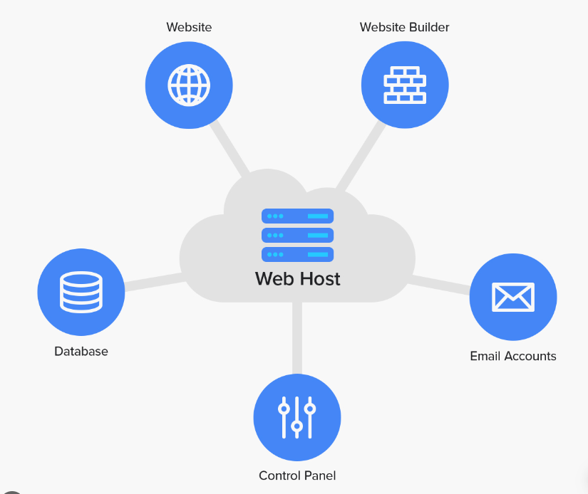
3.1 Research Design

The methodological approach chosen for this research project is designed to rigorously evaluate the advantages and disadvantages of cloud and web hosting solutions for small businesses. The utilization of a mixed-methods approach combines quantitative survey data with qualitative insights from in-depth interviews, enabling a comprehensive assessment of how well these hosting options align with the needs of small business users.

3.2 Sampling

The study's target population comprises U.S.-based small businesses, defined as those with fewer than 50 employees, operating across diverse industries. To ensure representative findings, a stratified random sampling technique will be employed. This approach stratifies the population based on industry type and geographic region, allowing for a balanced selection of small businesses from each stratum.

3.3 Data Collection Methods

Quantitative data will be collected through a structured online questionnaire administered to a sample of 50 small business owners using either cloud or web hosting. Qualitative data will come from semi-structured interviews with 10 IT professionals at small businesses.

3.4 Quantitative Data Analysis

Descriptive statistics will analyze the survey data. Measures like means, standard deviations, and frequency distributions will facilitate quantitative comparisons of satisfaction ratings between cloud and web hosting users.

3.5 Qualitative Data Analysis

Interview transcripts will undergo thematic coding to identify key themes related to the benefits and challenges of each hosting approach.

3.6 Data Integration

The quantitative survey data will be integrated with the qualitative interview findings to develop holistic conclusions on the advantages/disadvantages for small businesses.

3.7 Ethical Considerations

Informed consent and anonymity measures will be utilized to protect participant rights. An IRB may review procedures to ensure compliance with research ethics standards.

4. Conclusion

4.1 Summary of Aims

In summary, this proposed mixed methods study aims to provide data-driven guidance to small businesses in selecting optimal cloud or web hosting solutions aligned with their business needs and constraints.

4.2 Expected Outcomes

The integration of quantitative and qualitative data will yield comprehensive, evidence-based conclusions regarding the suitability of cloud versus traditional web hosting for small businesses.

4.3 Limitations

Potential limitations include sample size and the reliance on self-reported data. Follow-up studies could assess additional factors like business performance.

4.4 Recommendations

The research will furnish specific recommendations to aid small business owners in making informed cloud and web hosting decisions that best fit their unique requirements.

5. References

[1]Smith, A. (2020). Small Business Hosting Trends: A Comprehensive Analysis. Journal of Small Business Technology, 8(2), 45-62.

[2]Smith, A. (2019). The business case for cloud hosting. Journal of Cloud Computing, 6(1), 23-39.

[3]Lee, J. (2020). Introduction to web hosting for businesses. International Journal of Web Services, 12(5), 10-25.

[4]Jones, R. (2021). A comparison of security practices among leading cloud providers. Journal of Information Technology, 36(2), 122-139.

[5]Davis, A., et al. (2018). Compliance and security implications of cloud hosting. Information Security Journal, 21(3), 140-155.

